Examples and Intuitions II

The Θ^{(1)}Θ(1) matrices for AND, NOR, and OR are:

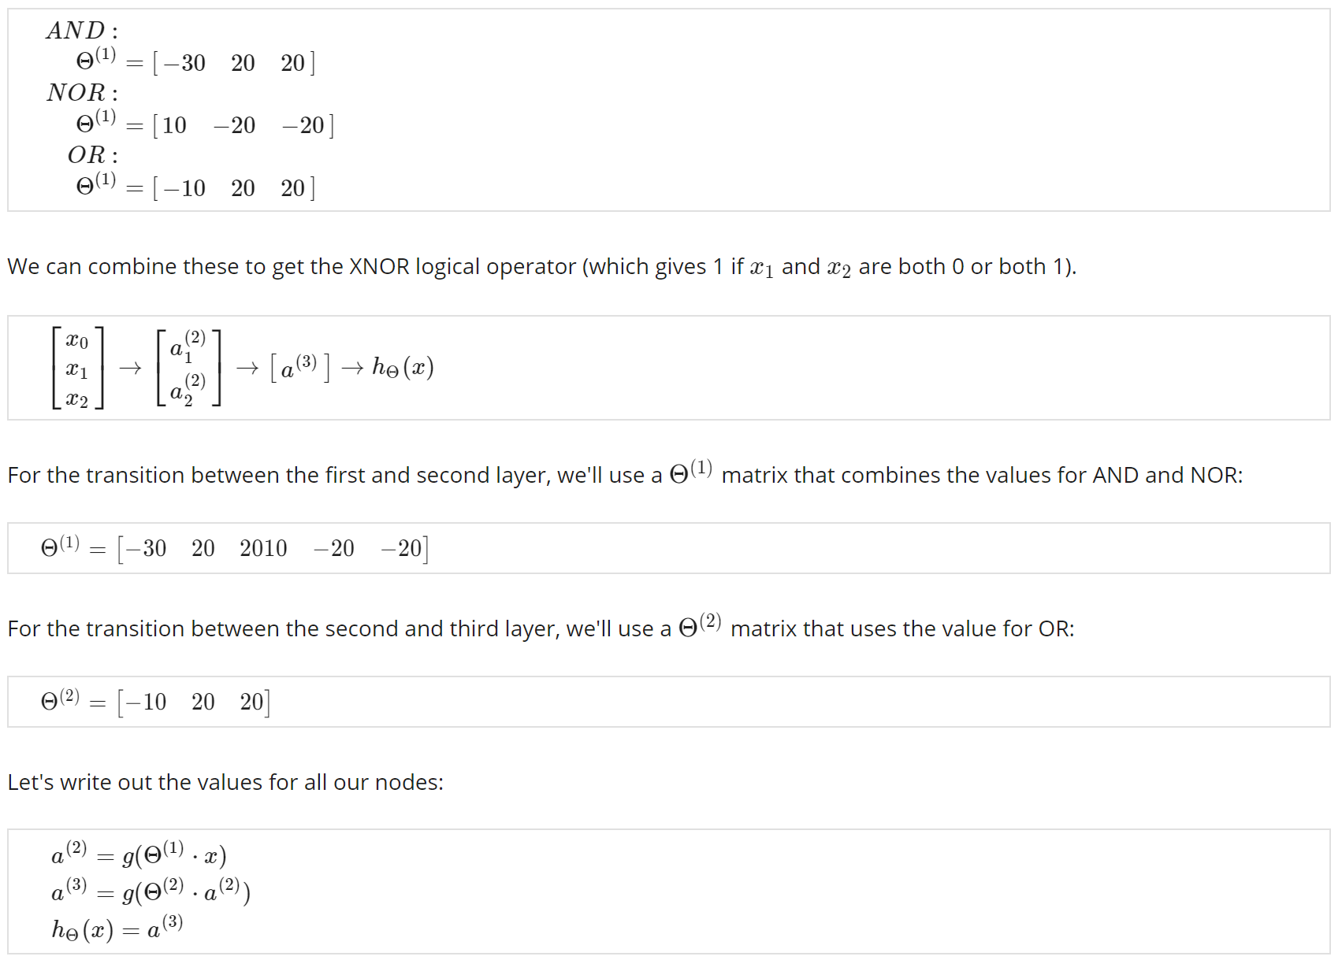

And there we have the XNOR operator using a hidden layer with two nodes! The following summarizes the above algorithm:

